**DBMS ASSIGNMENT**

**Name :** Anik Dutta

**Enrollment no:**

**Registration no:**

**Stream:** CSE

1.

create table customer (cust_id int ,

cust_fname varchar2(100) ,

cust_lname varchar2(100) ,

territory varchar2 (100) ,

cred_lmt int ,

mngr_id int ,

marital_status varchar2(100) ,

sex varchar2(30) ,

income int );

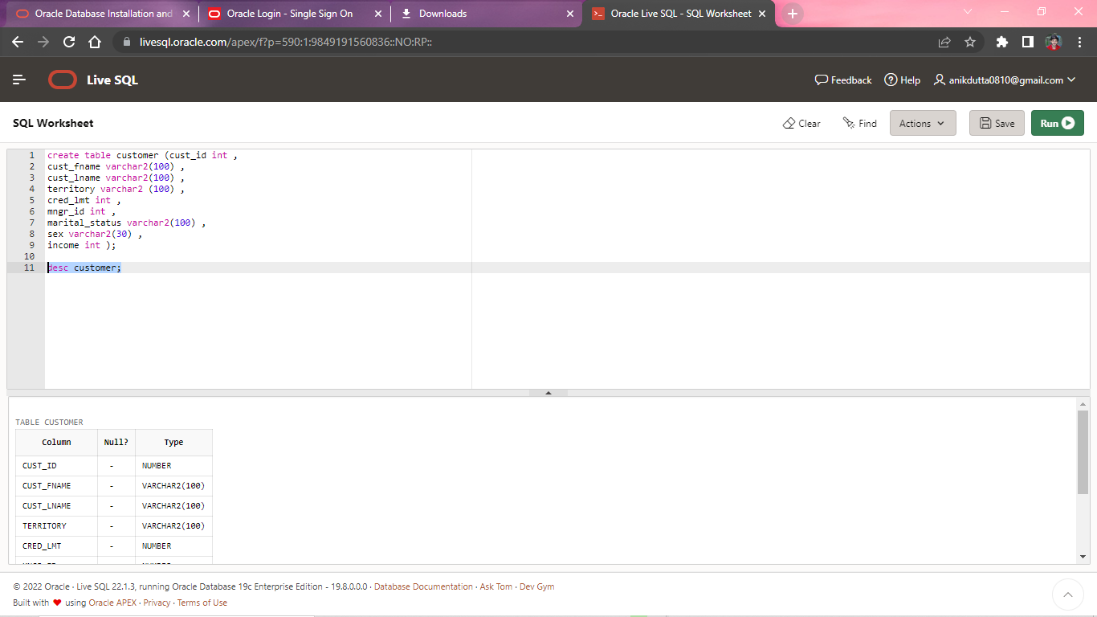

insert into customer(cust_id , cust_fname , cust_lname , territory , cred_lmt , mngr_id , marital_status , sex , income) values

(01, 'Rahul','Singh','India', 10000 , 112 , 'Single' , 'Male' , 65000);

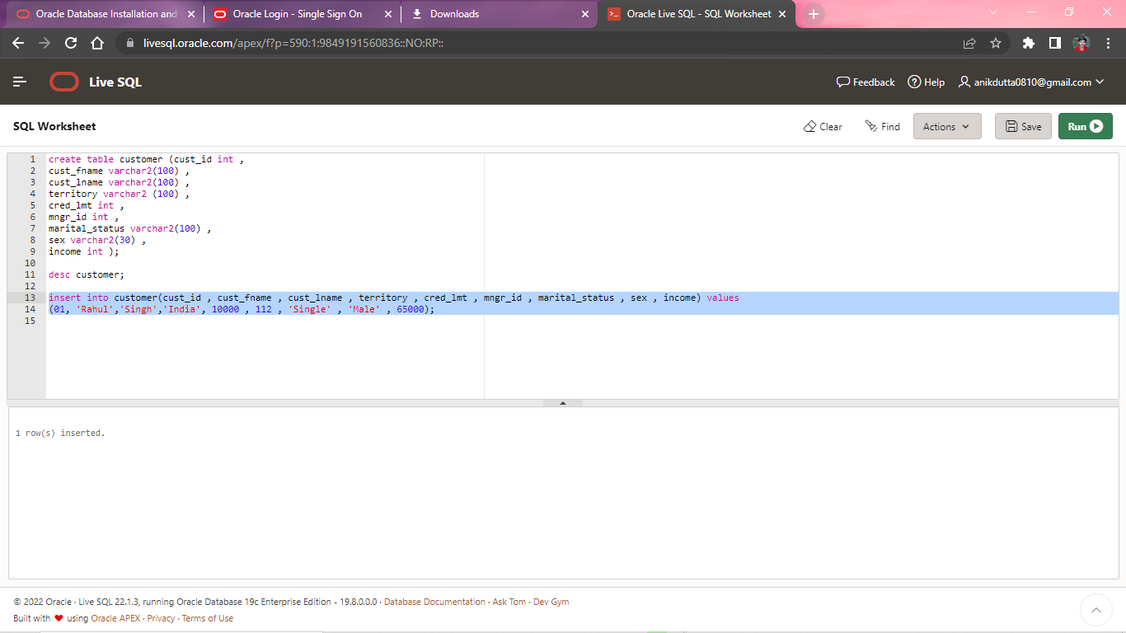

insert into customer(cust_id , cust_fname , cust_lname , territory , cred_lmt , mngr_id , marital_status , sex , income) values

(02, 'Meg','Sen','India', 15000 , 113 , 'Married' , 'Male' , 67000);

(03, 'George','Matthew','Italy', 12000 , 114 , 'Single' , 'Male' , 63000);

(04, 'Jennifer','Lopez','America', 14000 , 115 , 'Married' , 'Female' , 68000);

(05, 'Robert','Jhonson','Australia', 15000 , 116 , 'Married' , 'Male' , 65000);

(06, 'Meghna','Chakraborty','India', 15000 , 117 , 'Married' , 'Female' , 65000);

select * from customer ;